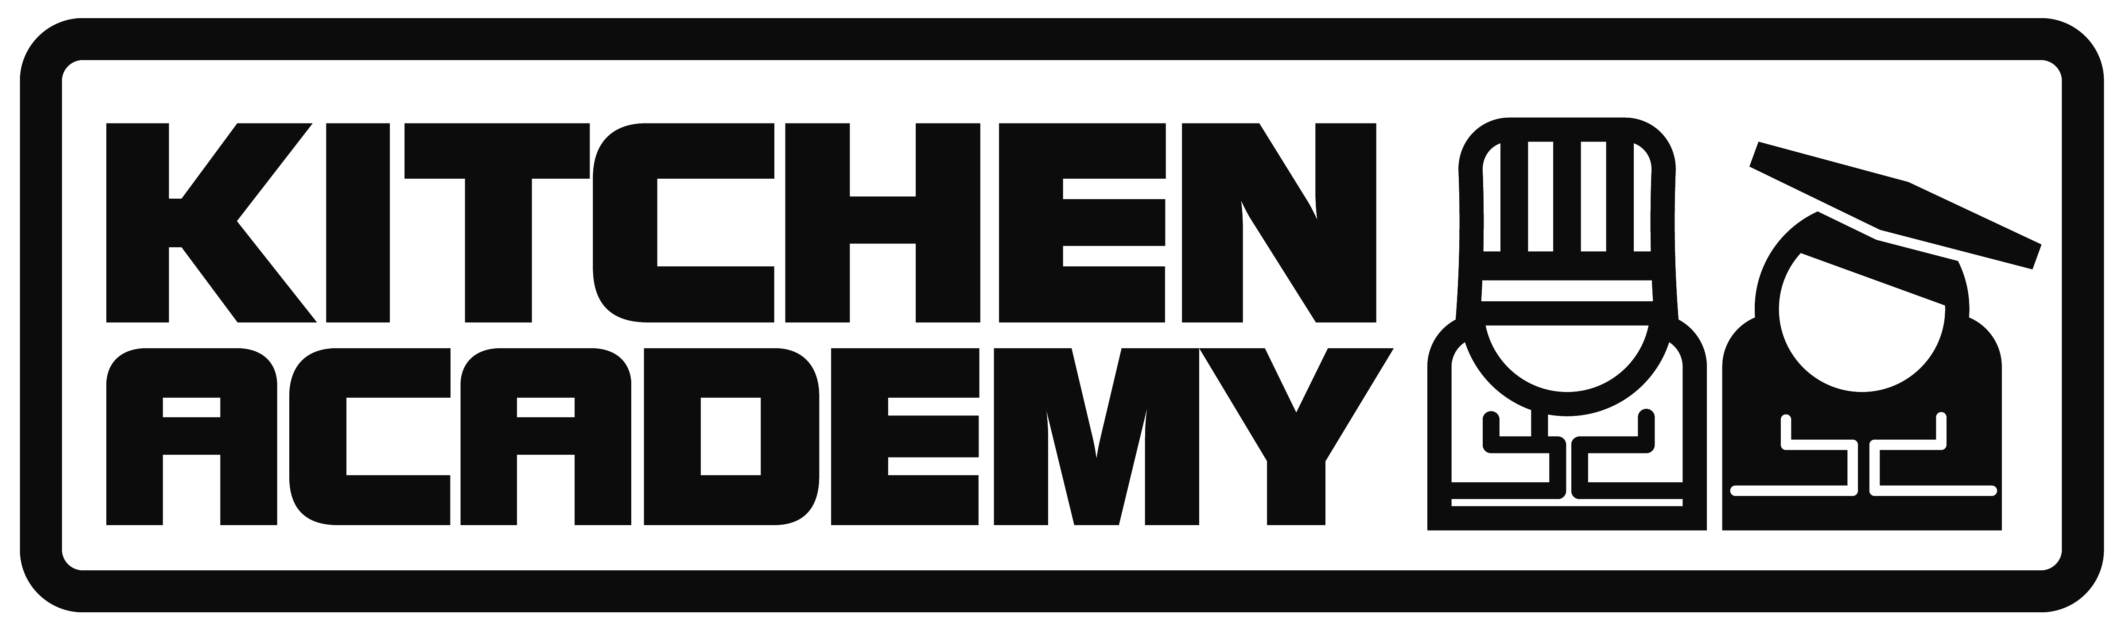

Kitchen Academy Services Request Form

Date of Event:

Contact Details
Company Name
Contact Name
Phone
Email
Website
Site Contact if different on the day
Address

Event Details
Venue
Event Type/Theme
Services Booked. i.e. Cookery Workshops, Cookery Demos, Smoothies Bikes.
Please see the list of services below.
Estimated numbers Total
Number of Workshops
Arrival Time
Depart Time
Age Range
Requirements for services
Can you provide the following
Tables (workshops require 8, demo’s require 2)
Chairs
Electricity
Water for hand washing
Sinks for washing dishes
Venue space (Workshops require a minimum of 8m x 8m. Demo’s require 3m x 2m)
Parking
First Aid

If you can provide any further details it would be much appreciated, i.e.
A suggested timetable for the day, Can lunch be provided for Kitchen Academy Staff? Is there a fridge or freezer available? Is there any dietary requirements or allergies?

We can also provide any health and safety documents on request, i.e. Public Liability Insurance, Food Hygiene, CRB Checks and Risk Assessments.

Our Services (costs should have been provided in an email, if you have not received these them you can request them by emailing info@kitchenacademy.co.uk)
Cookery Workshops: The cookery workshops are suitable for all age groups and can be tailored to your needs. The workshops have proven very popular at many schools and food festivals across the UK. They always have a buzz of excitement about them; participants will gain important skills in the art of cooking, creating fantastic dishes such as falafels, sushi and wraps. The workshops can run up to five times a day and can accommodate 30 students per session.
Rolling Cookery Workshops: This is a simple concept. We run a cookery session where participants spend 5 or 10 minutes with us. They help make a recipe that is quick, simple and healthy. The benefit of this is that larger volumes of participants can come through the workshops and learn recipes. It is less hands on than the normal cookery workshops but they are still involved. This works well if you have a large number of people and still want them to have a go at making something.
Open Cooking Demo: Some of our clients prefer to book a cookery demonstration. The main advantage of the demo is that they can be performed to large audiences in one sitting. Our chefs have performed demonstrations using the best ingredients available at food festivals, they have showcased produce at farmers’ markets and have got kids enthused about food in schools. Although there is no hands-on cooking for the audience the demo’s are always entertaining and the audience will go home more inspired and interested in cooking.
Smoothie Bike: We have had two Smoothie Bikes specially built for us. They often prove to be one of the most popular parts of an event. The child (or willing adult) rides the bike, and as if by magic a fruit smoothie is made! A novel way of exercising and getting a healthy reward at the same time. Just to let you know – the bike does remain stationary so thing won’t get too messy.
Human Fruit Machine: Our giant sized fruit machine is a fantastic concept. It has proved very popular with children in schools, at events and at birthday parties. Three children get inside the fruit machine where they will find a selection of fruit. When the fruit machine arm is pulled the children inside choose a fruit and present it through the opening in front of them. If the child at the front of the Human Fruit Machine gets three in a row then they win a healthy prize.
Gastronomic Experiments: This can be done as part of the Kids Kitchen Academy. The experiments give kids an insight into how different foods come about. We show children how to make their own butter, how to make salt out of seawater, how to make ice cream and much more.
We can provide:
Demonstration/workshop chefs
Induction Hobs
Ovens
All cookery equipment, utensils and ingredients
Chef hats and aprons
Smoothie Bikes

